Oracle Homework:

CHAPTER 8 Subqueries

For some of the following queries, the correct result can be obtained by using the join method. However, for this homework, you must use the sub-query method –DO NOT USE THE JOIN METHOD IN ANY QUERY. Name your queries ch8p1, ch8p2, etc.

Include the following comments at the top:
-- Your Name
-- Date
Put all of the queries in one script, and do not zip the file.

- Write a query to display the full name of all students who are enrolled in a course (that is, they have at least one enrollment in the ENROLLMENT table). Do not repeat any names. Label the column “Enrolled Students”.

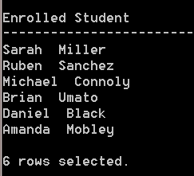
- Create a query to display the employee number, name, and salary for all employees who earn more than the average salary (the average for all employees) and are located in San Francisco (could be South or North San Francisco). Sort the results in descending order of salary.

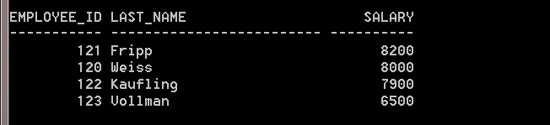
- Create a query to display the employee name, department number and salary for all employees who earn a salary equal to the average salary for their own department. (correlated subquery) Sort the results in order by employee name.
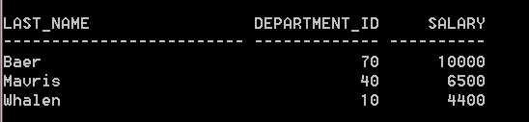

- Write a query to display the employee number, name, job and salary of all sales representatives (SA_REP) who earn more than any manager. (contain MAN or MGR in the job title.) Order by total salary.
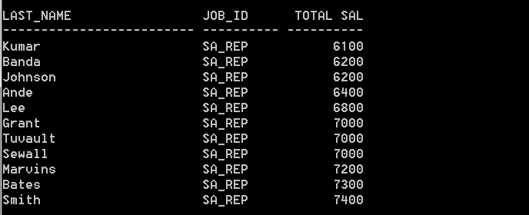

Etc.
30 rows selected.

- The HR department needs a query that prompts the user for an employee last name. The query then displays the last name and hire date of any employee in the same department as the employee whose name they supply (excluding that employee). For example, if the user enters Zlotkey, find all employees who work with Zlotkey (excluding Zlotkey).

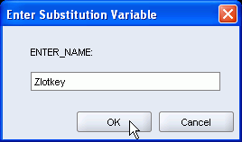

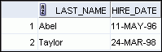

- Create a report for HR that displays the department number, last name, and job ID for every employee in the Executive department.
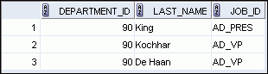

- Using the Animal Shelter schema, create a new problem using the features introduced in this chapter.

